Internship Report - Day 5
Name : Rickshtiha A
Intern ID : CDM/INT/202607608
Topic: Dataset Cleaning
Objective
The objective of Day 5 was to learn data cleaning techniques using the Pandas library. The focus was on handling missing values, removing duplicate records, and analyzing dataset statistics to prepare clean data for further analysis.

Tasks Completed
- Imported the Pandas library.
- Loaded the dataset.
- Explored dataset information.
- Identified missing values.
- Filled or removed missing values.
- Removed duplicate records.
- Generated statistical summaries.
- Saved the cleaned dataset.

Program 1 – Load Dataset
import pandas as pd

df = pd.read_csv("StudentsPerformance.csv")

print(df.head())

Program 2 – Dataset Information
print(df.info())
print(df.shape)
print(df.columns)

Program 3 – Check Missing Values
print(df.isnull().sum())

Program 4 – Remove Missing Values
df = df.dropna()

print(df.isnull().sum())

Program 5 – Fill Missing Values
df.fillna(0, inplace=True)
or
df.fillna(df.mean(numeric_only=True), inplace=True)

Program 6 – Remove Duplicate Rows
print("Before:", df.duplicated().sum())

df = df.drop_duplicates()

print("After:", df.duplicated().sum())

Program 7 – Dataset Statistics
print(df.describe())

Program 8 – Save Clean Dataset
df.to_csv("cleaned_student_data.csv", index=False)

Expected Outcome
- Dataset successfully loaded.
- Missing values handled.
- Duplicate records removed.
- Dataset statistics generated.
- Clean dataset prepared for further analysis.
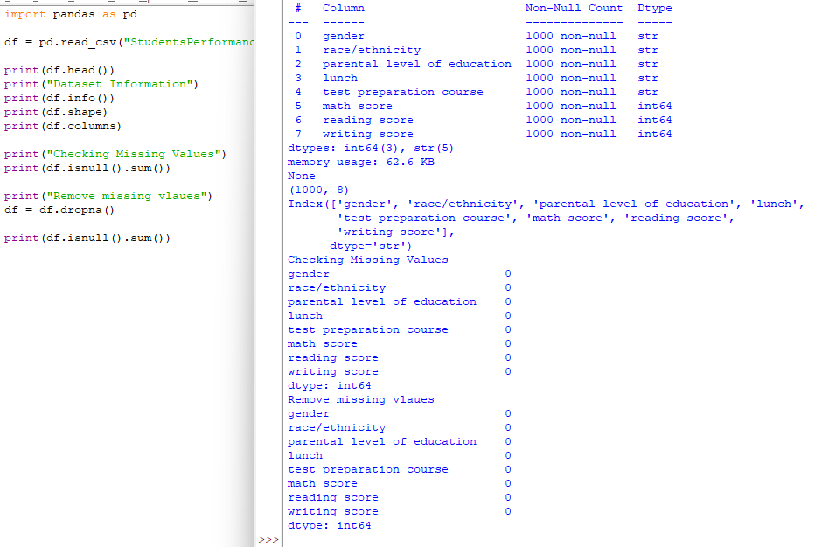
Learning Outcome
On Day 5, I learned how to clean real-world datasets using Pandas. I practiced identifying and handling missing values, removing duplicate records, and generating statistical summaries. These preprocessing techniques are essential for improving data quality before applying machine learning or data analysis methods.

